University of Washington

iSchool Info 340

# Module 02 Assignment - Enhancing a Database

In this module's assignment, you will learn how database designs are improved with the addition of constraints and abstraction layers.

## Assignment Videos

Please watch the following Videos:

|  |
| --- |
| Assignment Videos < 120 min (Links are to external sites) |
| [Common DB Options - Constraints - 45](https://youtu.be/A8pUl-BWRYg) |
| [SQL Data Definition Language - 18](https://www.youtube.com/watch?v=NxhJzdMQnlQ) |
| [Using the SQL Diagramming Tool - 17](https://youtu.be/jhCwk4Bpi0M) |
| [Using a MetaData Spreadsheet](https://youtu.be/angniIotJW4) - 2 |

## Assignment Examples

Read and try out some SQL statements on the W3Schools website. This website has short articles about many subjects and we will use this site throughout the course. In many of these articles you will find a "Try it Yourself" section where you can experiment with the SQL language interactively.

This website will become one of your most used "Go To" sites as you progress in your learning. So please check out the following pages this week!

|  |
| --- |
| Examples < 60 min (Links are to external sites) |
| [SQL Constraints - 5](https://www.w3schools.com/sql/sql_constraints.asp) |
| [SQL Not Null - 5](https://www.w3schools.com/sql/sql_notnull.asp) |
| [SQL Unique - 5](https://www.w3schools.com/sql/sql_unique.asp) |
| [SQL Primary Key - 5](https://www.w3schools.com/sql/sql_primarykey.asp) |
| [SQL Foreign Key - 5](https://www.w3schools.com/sql/sql_foreignkey.asp) |
| [SQL Check - 5](https://www.w3schools.com/sql/sql_check.asp) |
| [SQL Default - 5](https://www.w3schools.com/sql/sql_default.asp) |
| [SQL Index -5](https://www.w3schools.com/sql/sql_create_index.asp) |
| [SQL Auto Increment -5](https://www.w3schools.com/sql/sql_autoincrement.asp) |
| [SQL Views -5](https://www.w3schools.com/sql/sql_view.asp) |

## Assignment Reading

Since the course does not have an official text you will use various websites for your studies. This is a great way to learn new subjects and practicing it will be something you will use for years to come! Please read the following web pages:

|  |
| --- |
| Reading < 120 min (Links are to external sites) |
| [https://en.wikipedia.org/wiki/Relational_model - 60](https://en.wikipedia.org/wiki/Relational_model%20-%2060) |

## Assignment Document

Write a one-page document that articulates the answer to the following questions. Use at least one well-formed paragraph per question. Using only a sentence or two is fine, but it must make sense and be well formed. (Please use MS Word or a compatible word processor)

1. Explain the purpose of database constraints.
2. Explain the benefits of an abstraction layer.
3. Discuss the purpose and ERD and Meta-Data worksheet.
4. Explain the steps involved with designing a simple database.

**Note**: All resources for this assignment can be found in the lectures, recommended reading, or recordings specified in the class syllabus. You do not need to locate additional resources, outside of these.

***Important:*** *Your document must look professional to get full points! Use my example template and video, in the General Files and Topics module, as a guide for what I expect a professional paper to look like. Make sure you format it like a college paper instead of the text message. Things like your name, date, class, citations, introductory and summary paragraphs are always expected! Not putting these in the document you will cost you!*

## Assignment Task

I would like you to practice what you have learned in this module. You will write a SQL Script that creates a database called **Assignment02DB_YourNameHere**. The database you design and create will be to hold the following data (though for now we will leave it empty):

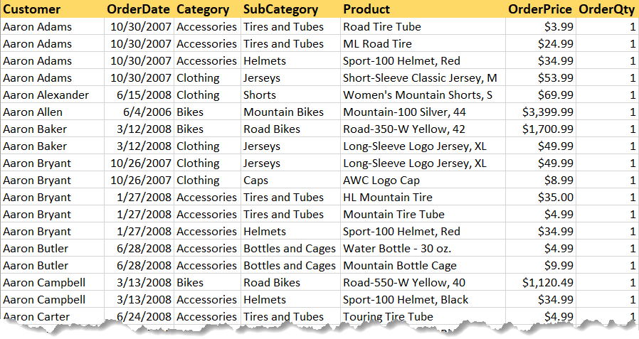

NOTE: This database must include tables with proper constraints and views for an abstraction layer.

Make sure you place a developer header at the top of your script, you include the questions, and your SQL code. Your final script should look like this one:

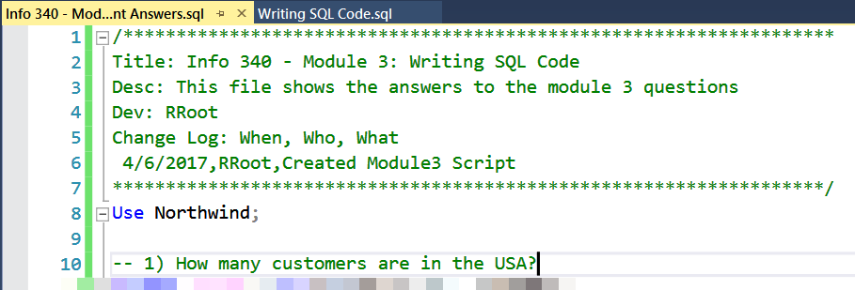

**Note**: Not putting your name, course, and date at the top of the document you will cost your 25% of your grade.

# Grading

Student work will be evaluated on a point system using the following general guidelines found on the Course Syllabus page. Make sure you read and understand this.

**NOTE:**  It is very possible to get a 3.9 or better from this course, but you have to earn it! Do not expect to get 100% of the possible points without extra effort on your part. If you want to excel in this course, you must submit **excellent**work!

# Submit your work

After you have completed your Word document and SQL Script, place both into a folder called Assignment02**FirstInitialLastName** and Zip the folder. Upload the Zipped folder to the Canvas web site.

